TASK 3

A password generator is a useful tool that generates strong and random passwords for users. This project aims to create a password generator application using Python, allowing users to specify the length and complexity of the password.

User Input: Prompt the user to specify the desired length of the password.

Generate Password: Use a combination of random characters to generate a password of the specified length.

Display the Password: Print the generated password on the screen.

CODE:

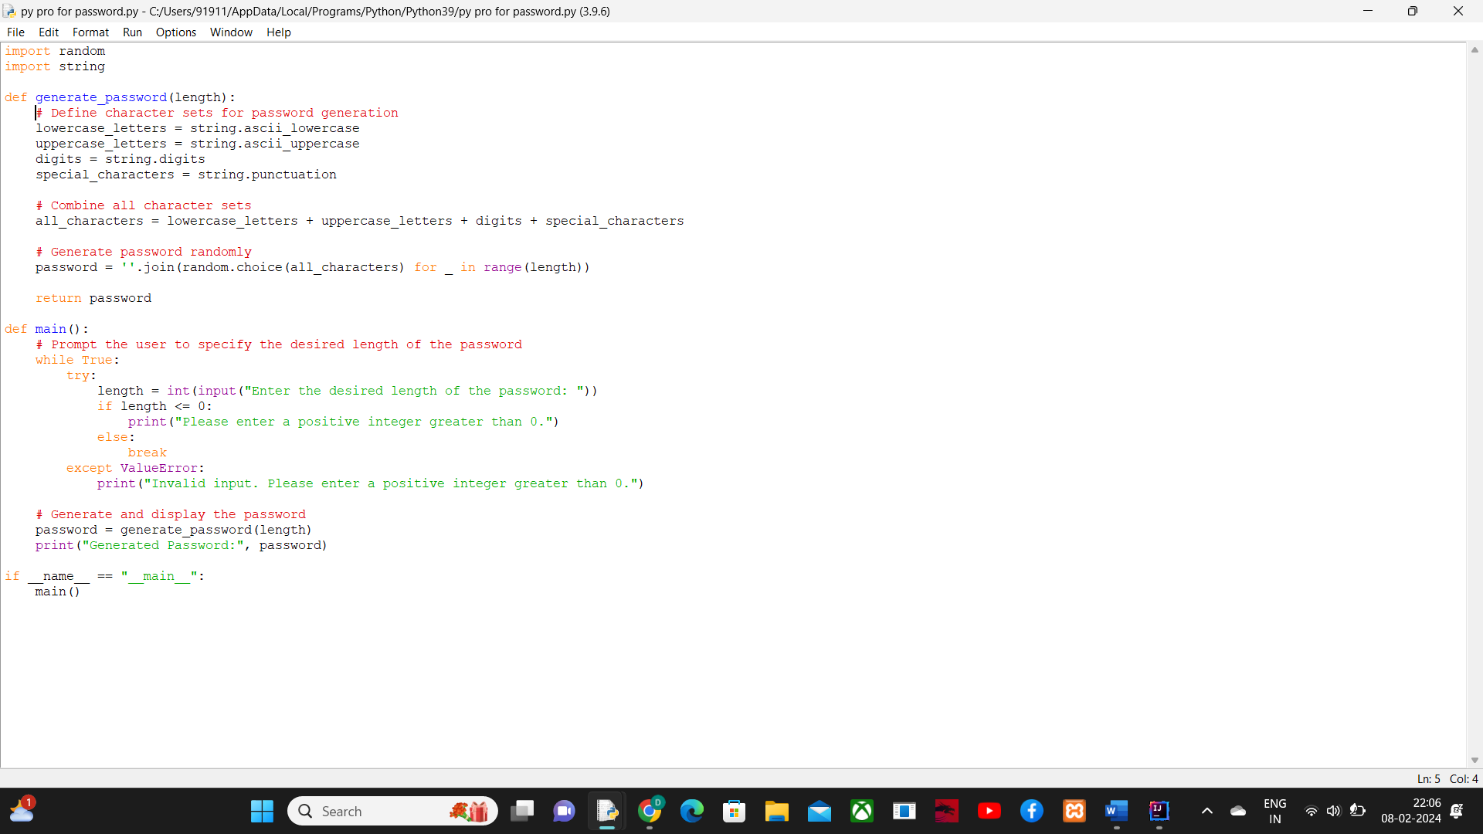

OUTPUT:

